Name:
Date:
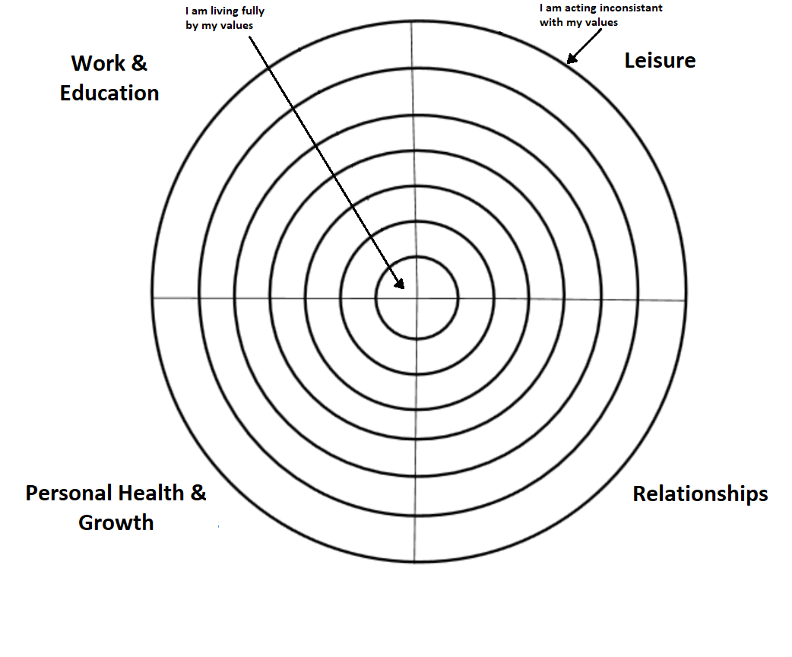
Instructions: Please write down your values under each of the four subheadings (Work Education, Leisure, Personal Health & Growth, and Relationships). Please an X in each quadrant of the bull’s eye in order to determine how closely you are living in accordance with your values.

